JEPonline

Journal of Exercise Physiologyonline

Official Journal of The American
Society of Exercise Physiologists (ASEP)

ISSN 1097-9751
An International Electronic Journal
Volume 3 Number 4 October 2000

Special Populations

Prediction Of Oxygen Consumption In Cardiac Rehabilitation Patients Performing Arm Ergometry

STANLEY P. BROWN
Department of Physical Therapy, Southwest Baptist University, Bolivar, MO 65613

STANLEY P. BROWN Prediction Of Oxygen Consumption In Cardiac Rehabilitation Patients Performing Arm Ergometry. JEPonline, 3(4):74-80, 2000. A new arm ergometer equation was compared to the American College of Sports Medicine (ACSM) equation using 31 cardiac rehabilitation patients (8 women and 23 men) ages 36-83 yr. Arm ergometry was performed on a modified Monark 868 cycle ergometer in stages incremented by 150 kgm/min and 2 min rest periods. Oxygen uptake was measured continuously. Patients were in various stages of an outpatient cardiac rehabilitation program, and on a wide array of cardioactive medications at the time of testing. Actual oxygen cost was underestimated from 105 to 438 mL/min (p<0.05) by the ACSM equation over four workloads. A revised equation was produced based on the actual oxygen uptake-power output relationship. The resulting slope was lower and intercept approximately the same when compared to the current ACSM equation. The revised equation is: VO₂ (mL/min) = 2.16 (kgm/min) + 285 mL/min. This equation has an r of 0.94 and a standard error of estimate of 104 mL/min. Although, results suggest that it is appropriate to use the new equation to estimate oxygen consumption in cardiac patients, further work is needed to validate and test the accuracy of the new arm ergometer equation.

Key Words: Oxygen Cost, Oxygen Uptake, Regression

INTRODUCTION
Recent work has shown that the American College of Sports medicine (ACSM) leg ergometer equation is less accurate in predicting VO₂ from power output (in kgm/min) on the mechanically-braked Monark ergometer than those equations more recently formulated (1,2). These equations have been shown to be gender-specific, i.e., homogeneous equations developed for college-age males and females have different slopes and intercepts (2). More recently, data from the HERITAGE Family Study were used to produce a heterogeneous cycle ergometer equation that was based on male and female data, and which was also slightly better than the ACSM equation (3).

Since the original ACSM leg ergometer equation has been shown to be less accurate than newer ones more recently developed, there is also a need to determine the accuracy of the ACSM arm ergometer equation [VO₂ (mL/min) = (kgm/min x 3 mL/kg/min) + (3.5 mL/kg/min x kg body mass)], and whether this equation is suitable for cardiac rehabilitation patients, a population for which exercise prescriptions are often formulated with the use of VO₂ regression equations. Cardiac patients have been shown to have lower VO₂ values than do healthy subjects while performing the same workload (4). The relationship between VO₂ and power output is likely to be different for patients in a cardiopulmonary rehabilitation program when compared to healthy, young males and females due to alterations in central and peripheral cardiovascular resulting from: 1) the presence and multiple effects of a wide array of cardioactive medications, 2) the presence of a variety of past cardiac events and interventions, including myocardial infarction and cardiac surgery, and 3) subject age and fitness level.

Brown and co-workers (5) produced a regression equation from arm ergometer exercise responses of 31 cardiac rehabilitation patients who varied with respect to gender, age, cardiac medical history, and stage of cardiac rehabilitation. The purpose of this analysis was to produce a heterogeneous rather than a homogeneous regression equation that could be applicable to any cardiac patient undergoing rehabilitation. This equation: VO₂ (mL/min) = 253.381 - 2.001 (age) + 2.947 (body mass) + 9.764 (Watts) + 0.026 (Watts²) has a strong multiple correlation coefficient of 0.96 and a very low standard error of estimate of 90 mL/min. However, the equation is cumbersome to use because of the number of independent variables it incorporates, and the requirement that power output in kgm/min be converted to Watts. These factors make direct comparisons to the ACSM and similar equations, which use only one independent variable, difficult. The purpose here, therefore, was to use the existing data (5) to develop a new arm ergometer equation based on one independent variable in order to compare it directly to the ACSM arm ergometry equation.

METHODS

The data that forms the basis of the current paper were used in an earlier published report that produced an arm ergometry regression equation using age, body mass, power output in Watts, and squared Watts to estimate submaximal VO₂ (5). In the current paper this data set is re-analyzed to produce an equation that is consistent with the ACSM equation (i.e., only one independent variable [power output in kgm/min] is used). The original sample consisted of 31 patients (8 women and 23 men) from a local hospital-based cardiac rehabilitation program and the surrounding community. The patients volunteered and gave informed consent in accordance with the Institutional Review Board of both the university and hospital. The mean and standard deviation (with the range) of patients’ age, body mass, and height are 62.6±11.2 yr (36-83), 83.0±17.4 kg (44.7-129.8), and 171.7±9.1 cm (154.3-185.4), respectively. Each patient was weighed to the nearest 0.1 kg, and the height was measured to the nearest 0.5 cm using a stadiometer on a medical grade scale. Twenty-one of the patients had a multivessel coronary bypass graft procedure and 12 of the patients were post-myocardial infarction. All of the patients were currently enrolled in either a Phase II or III cardiac rehabilitation program, or had graduated from such a program and were currently actively engaged in a home-conditioning program. The patients remained on their medication regimen for the exercise test. All patients were at least 12-weeks post-hospital discharge, and recent stress tests showed that their condition was stable. The study was limited to New York Heart Association function capacity classification Class I (>6 METS) and Class II (4 to 6 METS).

Patients made two visits to the laboratory, one visit to familiarize them to the facilities, and one visit to perform the exercise protocol. The exercise protocol was performed after fasting for a minimum of 3 hours, refraining from drinking caffeinated beverages for at least 6 hours, and avoiding heavy exertion or exercise for 12 hours before participation. All tests were performed in the morning under the supervision of a physician.

Patients performed intermittent arm ergometry (Monark 868 cycle ergometer affixed to a table top with removed foot pads) in 3 min stages that were separated by 2 min seated rest intervals. The ergometer height was situated to allow the crank shaft to be chest high and with enough distance to allow for a slight elbow bend at extension. Minor adjustments were required throughout the study to accomodate patients' different body sizes. The ergometer was calibrated every 7 tests using a known reference weight. No adjustments were required during the course of the study. An electronic metronome with an auditory signal was used to maintain the correct cranking rate, and verbal feedback was used to help patients stay on target with the proper crank rate. A revolution counter was used to track revolutions, with the counted revolutions used to calculate the average power output for each 3 minute stage. The exercise protocol was designed to begin at a power output of 150 kgm/min and to progress 150 kgm/min each stage. Cranking frequency was set at 50 rpm, which actually averaged ~52 rev/min throughout the study. Several patients were unable to follow pedal rate requirements very well, which resulted in an achieved workload ranging from 132.2 to 615.7 kgm/min. The patients performed 52.4±4.1, 50.7±4.7, 53.1±3.7, and 50.7±0.9 rev/min for stage 1 through 4, respectively.

VO₂ was measured continuously by the open circuit spirometric technique. Expired gas samples were measured every 15 sec throughout exercise with a SensorMedics Horizon Measurement Cart calibrated immediately before each exercise test using guaranteed commercially available zero (100% N₂) and precision (±0.01%) calibration gas preparations (4% CO₂/16% O₂) to set a zero and gain. The volume transducer was calibrated by delivery of a fixed volume at three different flow rates. Barometric pressure and temperature calibrations were also made. Patients wore a nose clip while breathing through a Hans Rudolph two-way valve system. Oxygen consumption values in mL/min during the last minute of each workload was used for statistical comparison. In all cases a steady-state VO₂ was achieved by the third minute of the test.

Steady-state VO₂ at each stage of testing was compared with the predicted values obtained from the new equation and the ACSM equation (6). A within factor 3 x 4 [VO₂ (three levels were measured, ACSM predicted, and New Equation predicted) by stage (4 levels)] two-way ANOVA with repeated measures was used to test differences between actual and predicted values. When a significant F appeared, a Newman-Kuels post-hoc analysis was used to determine specific differences. Simple linear regression was used to develop the equation with power output in kgm/min used as the independent variable and measured VO₂ responses as the dependent variable. The final equation was developed following the procedure previously used (1,2,7). This procedure subtracts an estimate of the resting metabolic rate of the patients (3.5 mL/kg/min x body mass in kg) which reduces the intercept of the equation. Typically, the intercept results in being the estimate of resting metabolism (3.5 mL/kg/min x body mass in kg) with an additional oxygen cost above this amount added to the intercept.

RESULTS
The omnibus repeated measures ANOVA revealed that there was a significant (p<0.001) difference between the mean VO₂ responses at each power output. The actual VO₂ was significantly lower than the VO₂ predicted from the ACSM arm equation, but not significantly different then the predicted VO₂ produced From the New Equation. The ACSM equation significantly over-predicted VO₂ in this sample of cardiac patients by 105, 296, 438, and 407 mL/min for stages 1 - 4, respectively (Figure 1). The average bias (difference between actual and predicted VO₂) for the ACSM equation was 311 mL/min, compared to 10 mL/min for the new arm equation revised by following the methods of Lang et al. (1). The new equation developed from the simple linear regression analysis: VO₂ (mL/min) = 2.16 (kgm/min) + 285 mL/min has a correlation coefficient or r=0.94 and a standard error of estimate of 104 mL/min. Figure 2 contains a scattergram and identity line for all actual and predicted VO₂ data pairs.

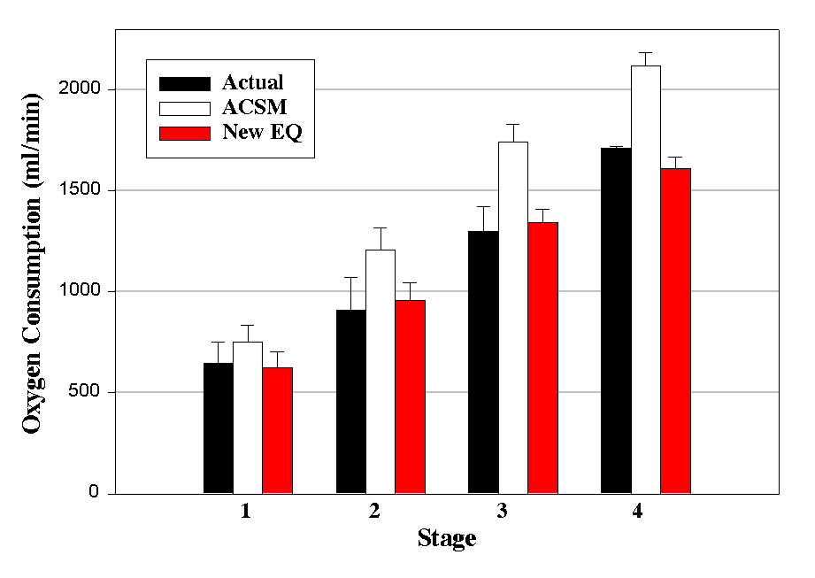
Figure 1. Measured vs predicted VO₂ using the ACSM and the new arm ergometry equation at each of the four stages of the arm ergometer exercise test. At each stage the ACSM equation significantly (p<0.001) over-predicts the actual value.

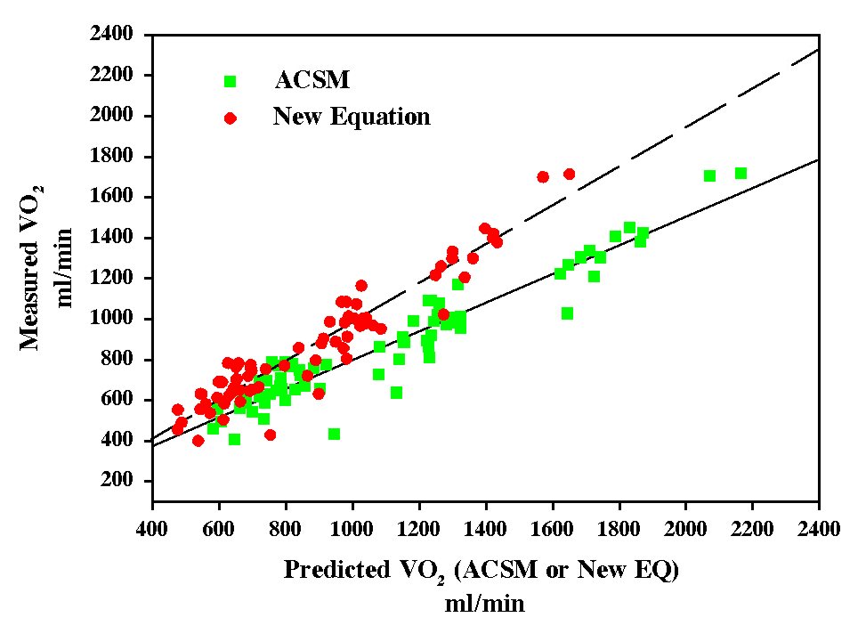
Figure 2. Scattergrams and identity lines plotted from actual and predicted (ACSM and New EQ) VO₂ (data pairs N=70).

DISCUSSION
The mean bias for the ACSM arm equation in the current study is higher than that produced by the ACSM cycle equation applied to obese women (8). The over-prediction by the ACSM arm ergometer equation in the current study is in contrast to the under-predictions reported in the literature (9), though of roughly the same magnitude. Under-predictions were also reported for the ACSM cycle ergometry equation (2,3,7). However, when using cardiac patients the ACSM treadmill equation has been shown to progressively over-predict VO₂ during treadmill walking (10). The over-predictions in the current study, therefore, are not unusual, and are probably a consequence of the population used (i.e., disease status).

The use of the ACSM equation to estimate VO₂ in this population results in over-predictions which may be due to the large anaerobic component relative to the total exercise energy expenditure. The large anaerobic component is due to large static contractions of the upper body musculature observed during arm cranking (11). This coupled with a reduced output of the heart due to a limited cardiac pump which is a general consequence of cardiovascular disease are likely explanations of the over-predictions seen here and elsewhere (10).

An additional likelihood for the over-predictions demonstrated in this study is that the devise used was a table-mounted Monark leg cycle ergometer. This device has a longer torque arm than the Monark Rehab Trainer which is more commonly used for arm testing and training in the cardiac rehabilitation setting. The longer torque arm is more mechanically efficient, which may reduce the oxygen cost of arm ergometer exercise.

Based on these data, Table 1 compares the slopes and intercepts for a 70 kg person cranking at 300 kgm/min. Whereas the intercepts are almost identical, the slopes are significantly (p<0.05) different. Since the slope and intercept of the ACSM arm ergometry equation are based on theoretical constructs only, and produce a difference in estimated VO₂, the new equation may provide a more accurate picture of the relationship between VO₂ and power output during arm ergometry in the cardiac population. After factoring in an estimate of resting metabolism per kg of body mass, the additional VO₂ was approximately 4 mL/min, which resulted in the final equation: VO₂ (mL/min)=(kgm/min x 2.16 mL/kgm ) + (3.5 mL/kg/min x kg body mass) + 4 mL/min. This equation, however, is population specific and should be applied to individuals matching closely the demographics of the sample used in this study. Additionally, the equation is used validly only at power outputs between 132 kgm/min and 615 kgm/min (cranking at approximately 50 rpm) which is the workload range patients achieved in this study.

The equation produced in the current study has an intercept of 285 mL/min which is almost identical to the average resting metabolic rate (calculated as 3.5 mL/kg/min x kg body mass) of this sample of cardiac patients. As mentioned in the current edition of ACSM's exercise prescription guidelines (6), an additional term for unloaded cycling, included in the leg ergometry equation as 7 mL/kg/min, is not needed in the arm ergometry equation because of the small mass of the arms. The results herein seem to support this statement as there was only a 4 mL difference when factoring in resting VO₂ to obtain the gross oxygen cost of arm ergometry. Adding 4 mL to the resulting prediction, therefore, is negligible and probably not needed.

Table 1. Slopes and intercepts for a 70 kg person cranking at 300 kgm/min.
 | Slope | Intercept | Total
ACSM | 900 mL | 245 mL | 1145 mL
Revised | 648 mL | 249 mL | 897 mL
Difference | 252 mL | -4 mL | 248 mL

CONCLUSIONS
These results demonstrate the necessity for further research to evaluate the new arm ergometer equation presented herein. While the data demonstrates that the ACSM equation was not accurate in this sample of cardiac patients, corroborative data via a validation study is necessary before sweeping recommendations regarding the new equation can be made. Further work should also be done on the use of the Monark Rehab Trainer. Direct comparisons of the oxygen cost of arm ergometry using the Monark Rehab Trainer versus a modified leg ergometer should be made before recommending the new equation presented in this study.

An important finding from this investigation is that the ACSM equation overestimates VO₂ when used in a cardiac rehabilitation setting, and that an equation with a slope of 2.16 mL/kgm may provide the clinician a more accurate determination of the oxygen cost of arm ergometry. The overestimation is a concern in clinical practice since this may result in prescribing exercise intensities above a therapuetic range. The new equation may be applicable to patients of either gender and to those on medications. While these concerns were expressed in an earlier paper that presented these data, an equation modeled after the ACSM equation as provided herein proves much more user friendly for clinicians than the equation previously developed (5).

REFERENCES
- Lang PB, Latin RW, Berg KE, Mellion MB. The accuracy of the ACSM cycle ergometry equation. Med Sci Sports Exerc 1992;24:272-276.
- Latin RW, Berg KE. The accuracy of the ACSM and a new cycle ergometry equation for young women. Med Sci Sports Exerc 1994;26:642-646.
- Stanforth PR, Ruthven MD, Gagnon J, Bouchard C, Leon AS, Rao DC et al. Accuracy of prediction equations to estimate submaximal VO₂ during cycle ergometry: The Heritage Family Study. Med Sci Sports Exerc 1999;31:183-188.
- Fletcher GF, Cantwell JD, Watt EW. Oxygen consumption and hemodynamic response of exercise used in training of patients with recent myocardial infarction. Circulation1979;60:140-4.
- Brown SP, Wu Q, Chitwood LF, Anderson ER, Dahl E, DeLashmit S. The prediction of oxygen consumption in cardiac rehabilitation patients during arm ergometry. J Cardiopulmonary Rehab 1994;14:
181-8.
- American College of Sports Medicine. ACSM’s guidelines for exercise testing and prescription (6th ed.). Baltimore: Williams and Wilkins, 2000.
- Latin RW, Berg KE, Smith PR, Tolle P, Woodby-Brown S. Validation of a cycle ergometry equation for predicting steady-rate VO₂. Med Sci Sports Exerc 1993;25:970-974.
- Andersen RE, Wadden TA. Validation of a cycle ergometry equation for predicting steady-rate VO₂ in obese women. Med Sci Sports Exerc 1995;27:1457-60.
- Allison TG, Reger WH, Millit HD. Actual versus ACSM-predicted VO₂ for the Monark rehab trainer. Med Sci Sports Exerc 1988;20:S1.
- Berry MJ, Brubaker PH, O’Toole M, Rejeski WJ, Soberman J, Ribisl PM et al. Estimation of VO₂ in older individuals with osteoarthritis of the knee and cardiovascular disease. Med Sci Sports Exerc 1996;28:808-14.
- Toner MM, Glickman EL, McArdle WD. Cardiovascular adjustments to exercise distributed between the upper and lower body. Med Sci Sports Exerc 1990;22:773-778.

Address for correspondance:
Stanley P. Brown*, Department of Physical Therapy, Southwest Baptist University, Bolivar, MO 65613
Phone: (417)328-1672, Fax: (417)328-1658, Email: spbrown@sbuniv.edu

*This work was originally performed in the Human Performance Laboratory, Department of Exercise Science and Leisure Management, The University of Mississippi.

